# Setting Up Application Environment

**Docker CLI Installation**

|  |  |
| --- | --- |
| Date | 24 OCT 2022 |
| Team ID | PNT2022TMID23214 |
| Project Name  Team members | Real time river water quality monitoring and control system  Saravana kumar M , Logesh P , Ram Kumar P , yogeshwaran M |

## Step 1:

[***install/***](https://docs.docker.com/desktop/install/windows-install/)

Go the official Docker website: [***https://docs.docker.com/desktop/install/windows-***](https://docs.docker.com/desktop/install/windows-install/)

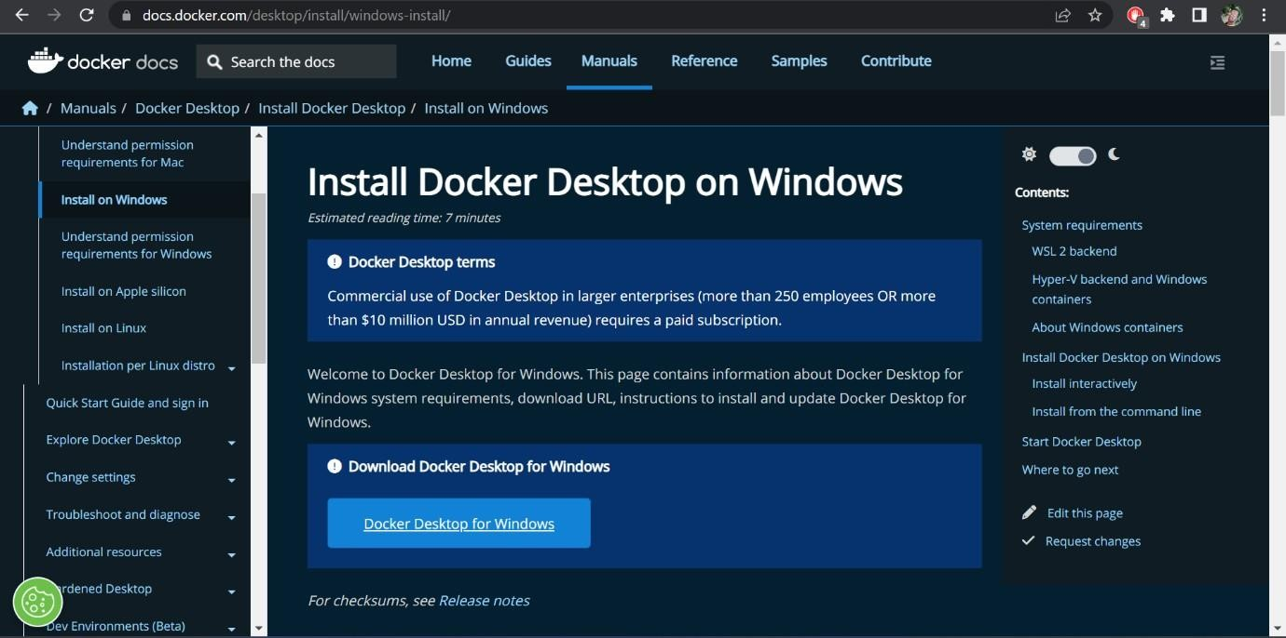

## Step 2:

Click that button (Docker Desktop for Windows) and download will start and it takes

few minutes to complete.

## Step 3:

Go to downloads in browser (or) type **ctrl + J**, it will navigate to download page and double-click the particular docker file.

## Step 4:

Now Installation is complete. This icon was added in your desktop. Double-click the icon to start the docker app, you can register and login that app to access those credentials.

## Step 5:

Docker will start correctly, the left bottom side was shown in green color, docker will

show the status of docker app working successfully.

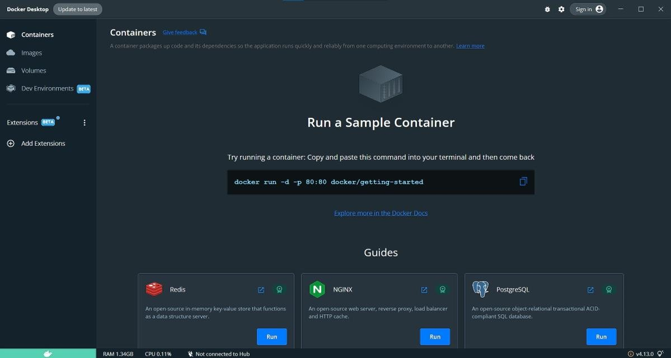

## Step 6:

Finally, the docker is installed successfully.